
Department of Computer Science and Engineering
Islamic University of Technology (IUT)
A subsidiary organ of OIC

Lab Report 0

CSE 4512: Computer Networks Lab

Name:Md. Abdullah Al Jubaer Gem
Student ID:210041226
Section:2B
Semester:Winter
Academic Year:2023-2024

Date of Submission:

Title: Familiarizing with the Packet Tracer environment

Objectives:
- Download and install Cisco Packet Tracer
- Learn about use-cases of Cisco Packet Tracer
- Get acquainted with different components of Cisco Packet Tracer environment
- Understand how to operate Cisco Packet Tracer

Note: For writing the report, you can take help from online resources. But you should not just copy and paste. Write in your own words. Also don't copy from any other student. When taking help from online resources, please provide appropriate references at the end of report.

Introduction:
(Write a brief intro on Cisco Packet Tracer. Don’t forget to mention its use-cases.)

Cisco Packet Tracer is a network simulation tool developed by Cisco, commonly used by beginners and students to learn about how computer networks work. It provides a virtual environment where users can design and simulate different types of networks using various devices like routers, switches, and PCs, all without needing physical hardware. This makes it useful for learning and experimenting with different configurations as it offers an easy way out to those with limited access to the networking tools and simulating the real world scenario risk free . So that it becomes easy to implement it later on.

Use-Cases of Cisco Packet Tracer:
- Network Design and Testing: Users can design their own networks by connecting virtual devices and running tests to see how they function. This is ideal for learning how networks are built and how different devices communicate with each other before deploying them in real-world scenarios.
- Learning Tool: Cisco Packet Tracer is widely used in networking courses, especially in Cisco’s Networking Academy, to help students practice what they learn. It’s a key tool for preparing for certifications like CCNA, as it allows hands-on experience without needing actual networking hardware.
- Troubleshooting Practice: The tool allows users to simulate common network problems and practice troubleshooting. This feature helps learners understand how to diagnose and resolve issues that can arise in real networks.
- Learning Protocols: Users can visualize how different networking protocols (like TCP/IP or OSPF) work and how data is transferred between devices. This helps beginners grasp how network communication happens and what protocols do behind the scenes.
- Exploring IoT and Security: Packet Tracer also supports the simulation of Internet of Things (IoT) devices and network security features. This lets users experiment with modern technology and learn how to implement secure networks by configuring firewalls and access controls.

Interface of Cisco Packet Tracer:
(Explain the options/elements available in each of the interface listed below with necessary screenshots. For example, you can explain what a switch is with a sample switch from device-specific selection box, what are the options available inside a switch etc.)
P.S. Do Not Copy Paste From Others

- Menu Bar:
The following screenshot indicates the Menu Bar of the Cisco Packet Tracer

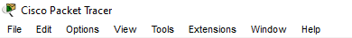

Some basic functionalities available here are as follows:
File , Edit , Options , View , Tools , Extensions , Window , Help
These allow you to manage projects, configure settings, and adjust the display. For instance, you can save, open network simulations, or adjust preferences like grid alignment.

- Main Tool Bar:
The following screenshot indicates the Main Tool Bar of the Cisco Packet Tracer
This toolbar offers quick access to essential tools such as zoom, undo, redo, and the ability to create or delete network components. Icons here are used for navigation and quick editing of the workspace.

- Logical/Physical Workspace and Navigation Bar:
The following screenshot indicates the Logical/Physical Workspace and Navigation Bar of the Cisco Packet Tracer

The workspace, split into Logical and Physical views, lets you manage the network layout. The logical view shows devices and connections in a structured, 2D interface, while the physical view represents actual hardware placement. The navigation bar allows quick toggling between these views.

- Realtime/Simulation Bar:
The following screenshot indicates the Realtime Simulation Bar of the Cisco Packet Tracer

Located at the bottom-right corner, this bar lets you switch between Realtime and Simulation modes. In Realtime mode, devices function as they would in real-time. The Simulation mode lets you monitor network events and data transfer in a stepwise, slowed-down fashion, useful for debugging.

- Network Component Box:
The following screenshot indicates the Network Component Box of the Cisco Packet Tracer

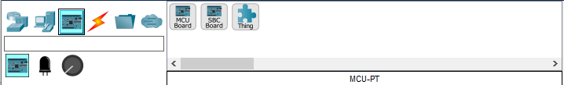

This box at the bottom-left contains all available network devices (e.g., routers, switches, end devices). You can drag and drop these components into your workspace to build network topologies.

- Device-type Selection Box:
The following screenshot indicates the Device-type Selection Box of the Cisco Packet Tracer

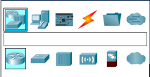

This section, also at the bottom-left, allows you to choose categories of devices such as routers, switches, wireless devices, etc. It's a filtered view of network devices, simplifying the process of selecting specific device types.

- Device-specific Selection Box:
The following screenshot indicates the Device-specific Selection Box of the Cisco Packet Tracer

Once you select a device type, this area displays the available models for that category. For instance, after selecting routers, you will see specific Cisco router models like the 1841, 2811, and others.

- User Created Packet Window:
The following screenshot indicates the User Created Packet Window of the Cisco Packet Tracer
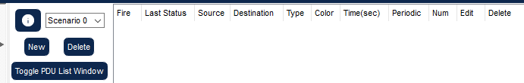

This window shows details of the PDU List (Protocol Data Units) during simulations, including packet destinations, protocols, and status.

Key Features of Cisco Packet Tracer:
- Network Simulation: Lets you create a virtual network with routers, switches, and computers to test how everything connects without needing real devices.
- Real-Time and Simulation Modes: You can see the network working like it would in real life (Real-Time Mode) or slow it down to see how data moves step-by-step (Simulation Mode).
- Easy Drag-and-Drop: Just drag and drop devices to build your network, making it simple for beginners to set up connections and layouts.
- Supports Many Protocols: You can learn and practice using different network protocols (like TCP/IP, OSPF) to see how they work together.
- IoT and Security: You can add smart devices (IoT) and try out security features like firewalls to understand how to protect a network.
- Multi-User Collaboration: Multiple people can work together on the same network project at the same time, which is great for group learning.
- Built-In Learning Tools: Includes tutorials and scenarios that help guide you through setting up networks and solving common problems.
- Visual Packet Flow: You can watch how data moves through your network to better understand how information travels and how to fix issues.
These features make Packet Tracer an easy and useful tool for learning and practicing networking, especially for beginners.

Challenges faced and Solutions:

Having never used this software before I challenged quite a number of challenges and difficulty . So for finishing the tasks that I was assigned I heavily relied on the resources from the internet and such .
Still not having clear idea of how the software is supposed to be used and how real life networks work I made a number of mistakes some of which I was able to fix.

Lab Tasks

- 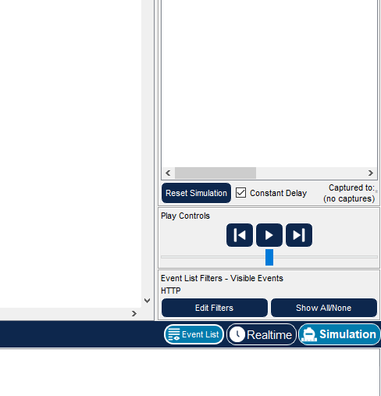
- 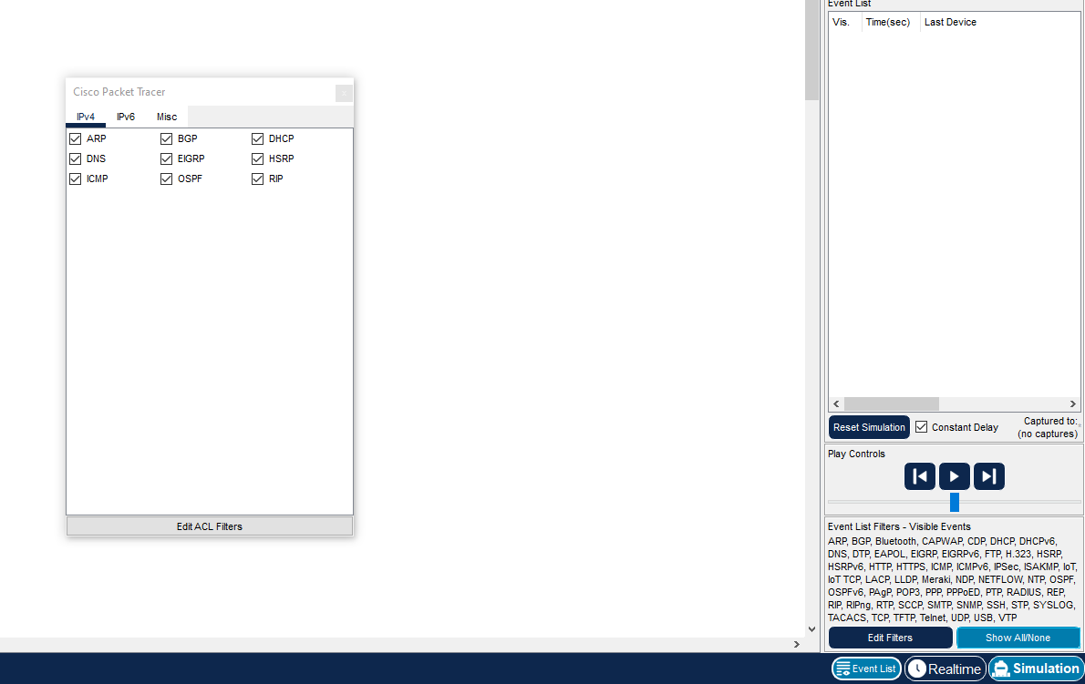

- 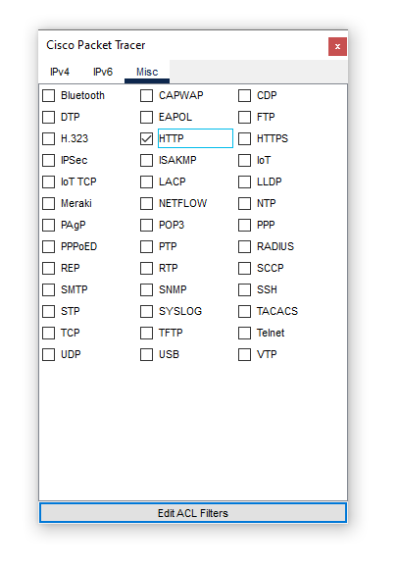
- 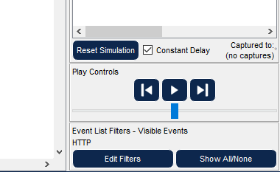
- 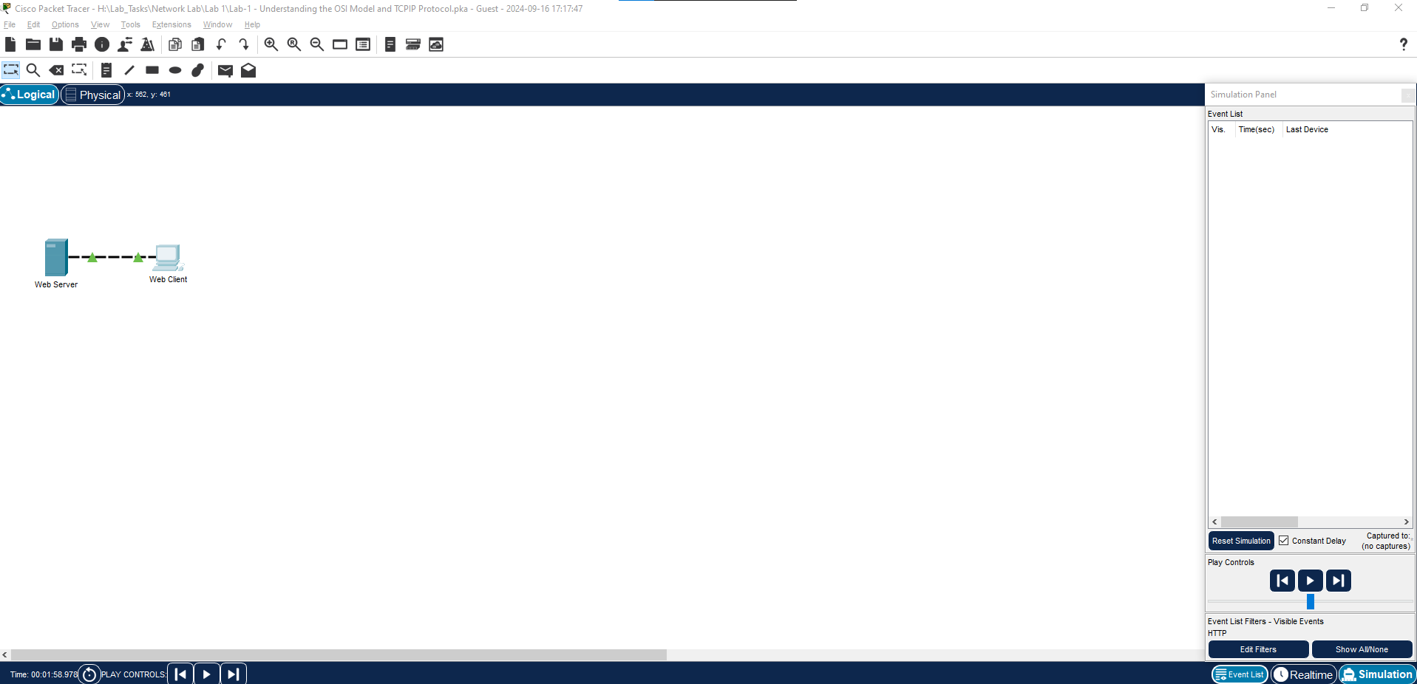
- 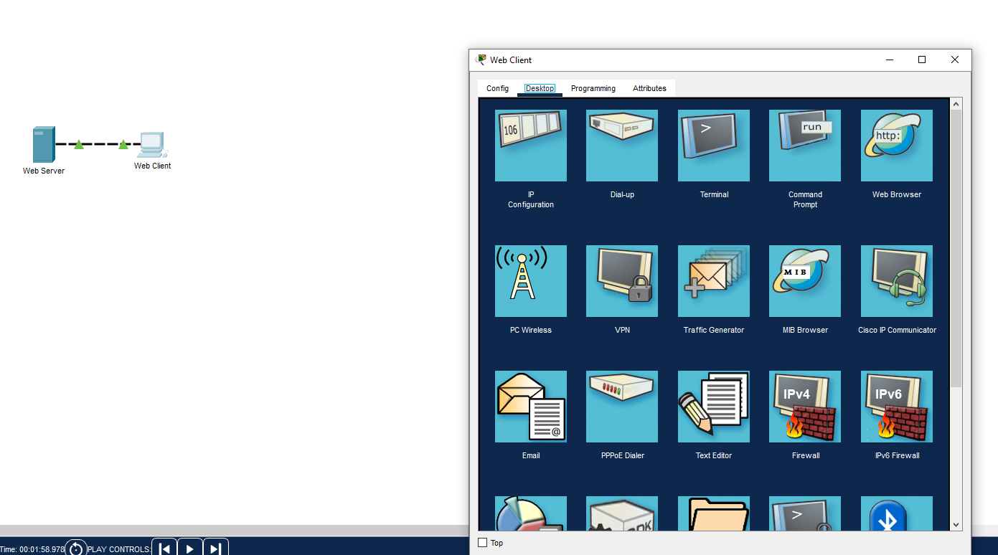
- 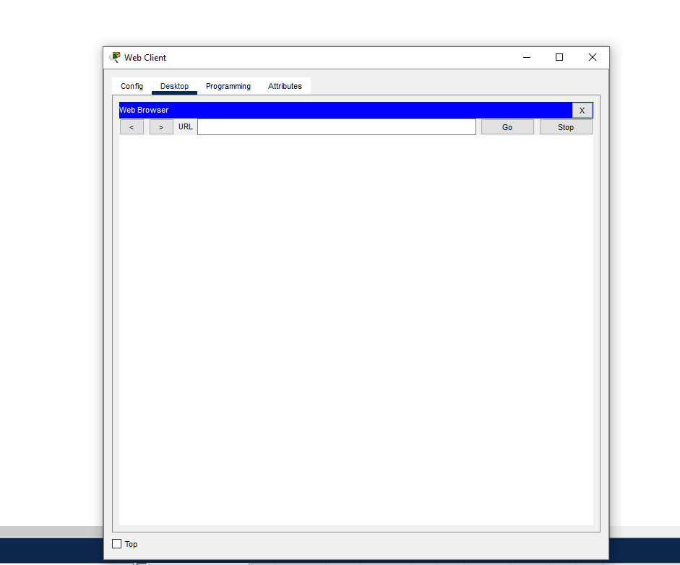
- 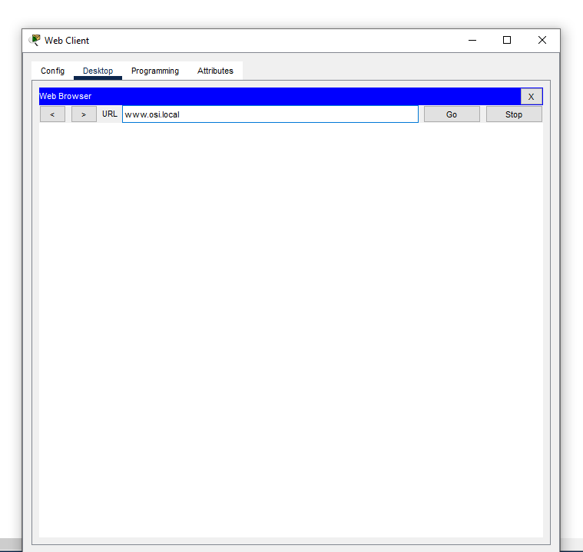
- 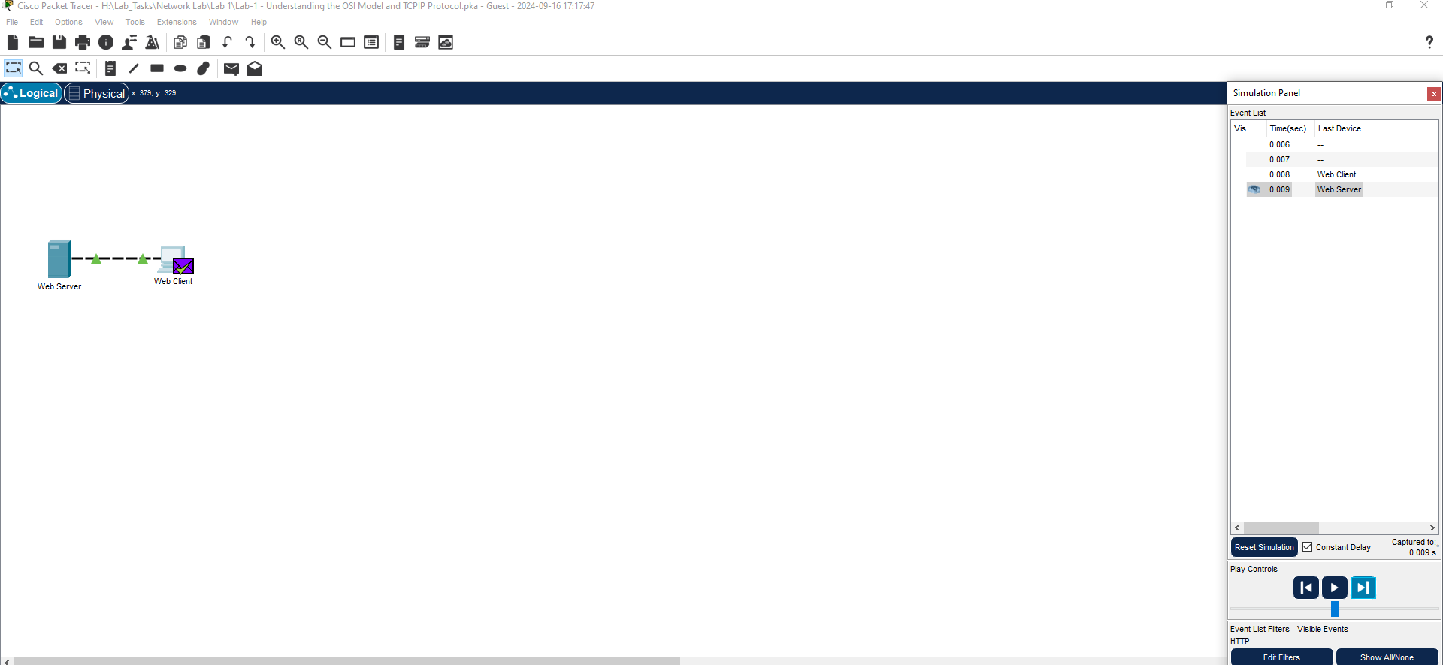
- 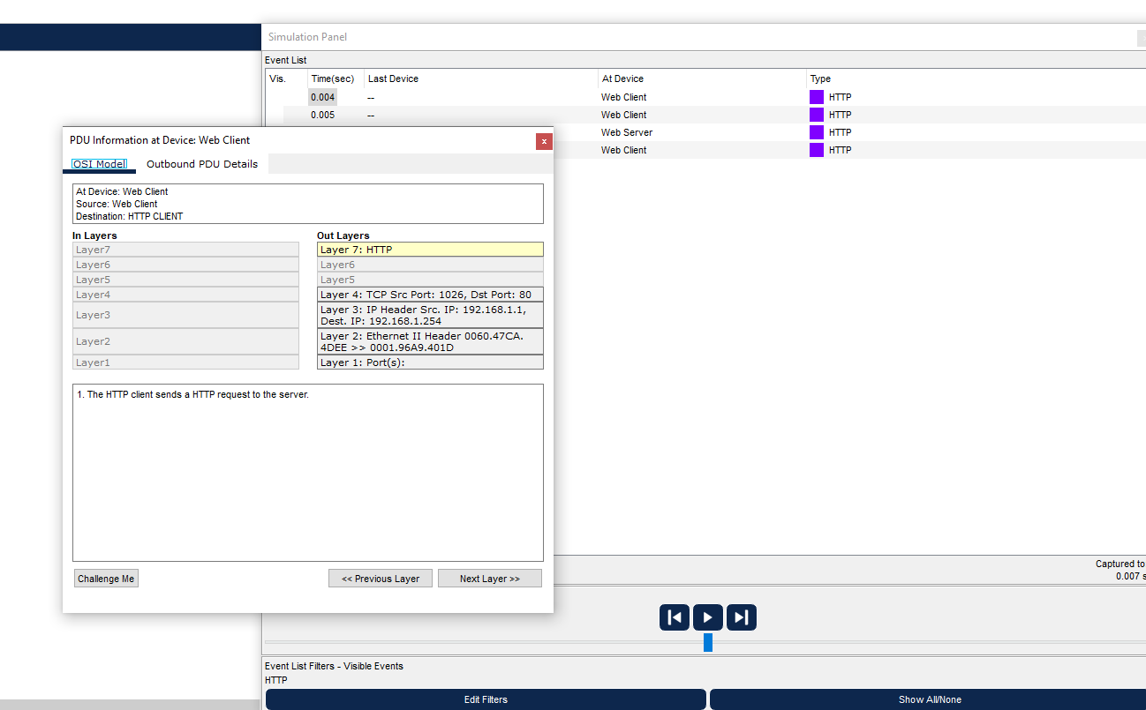
- 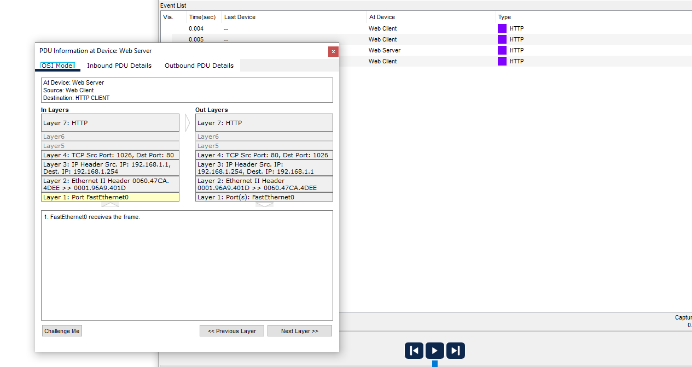
- 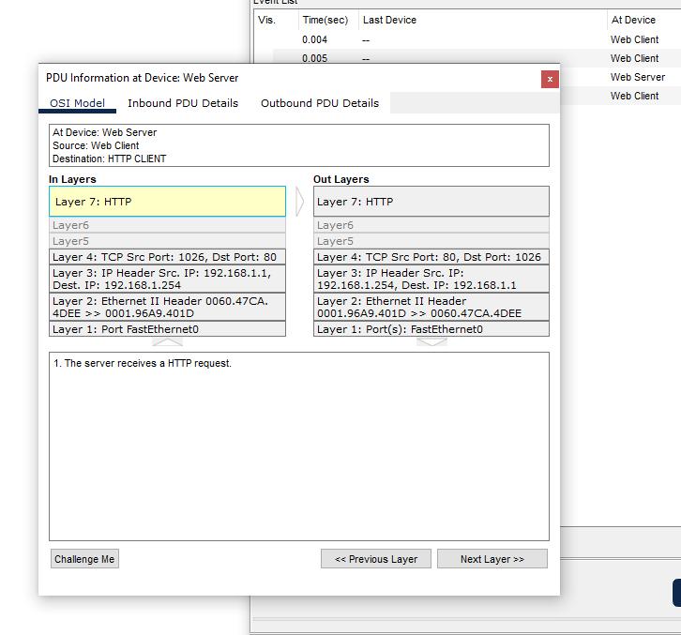
- 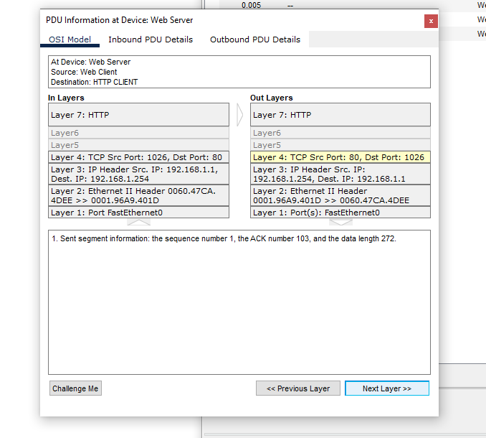
- 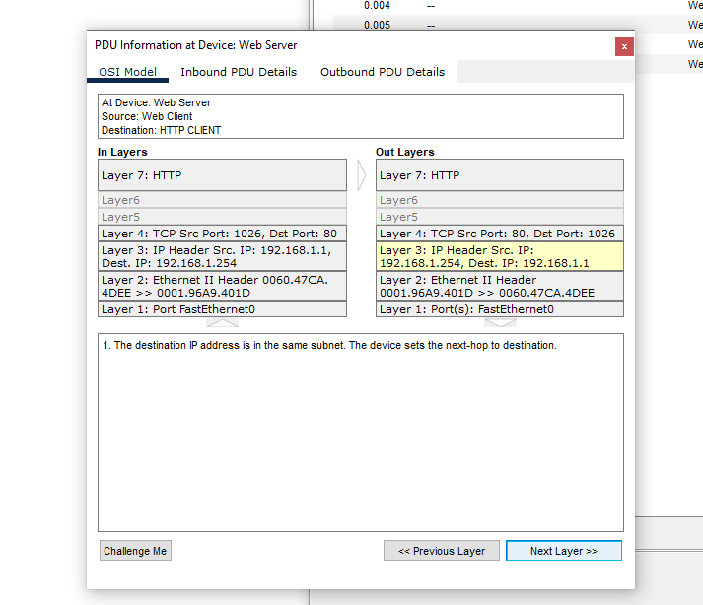
- 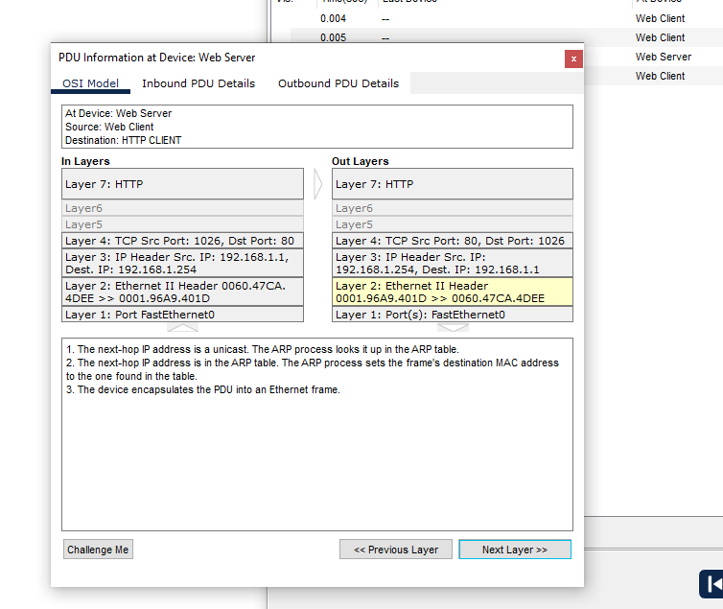
- 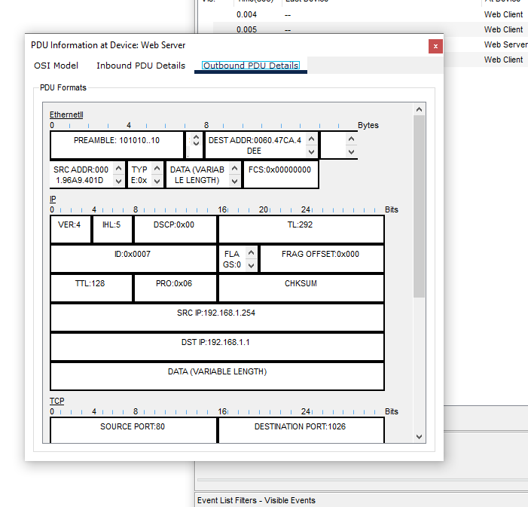
- 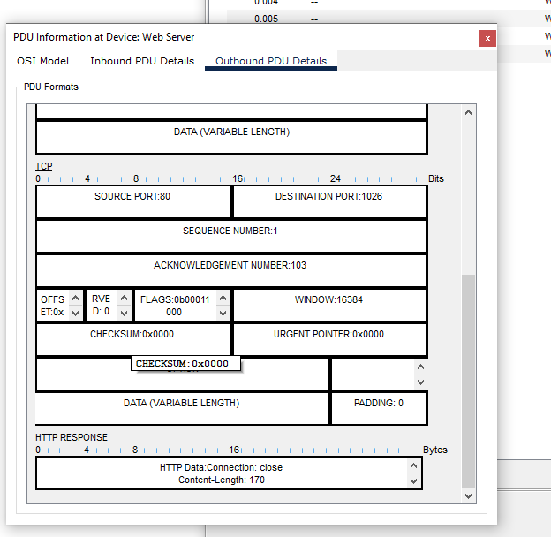
- 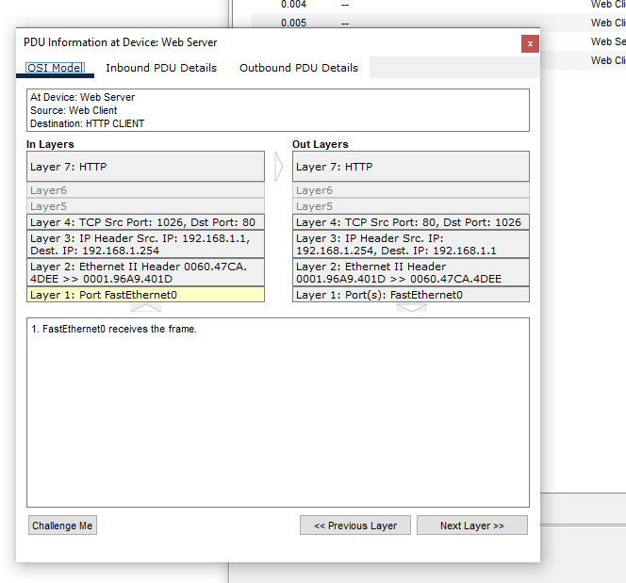
- 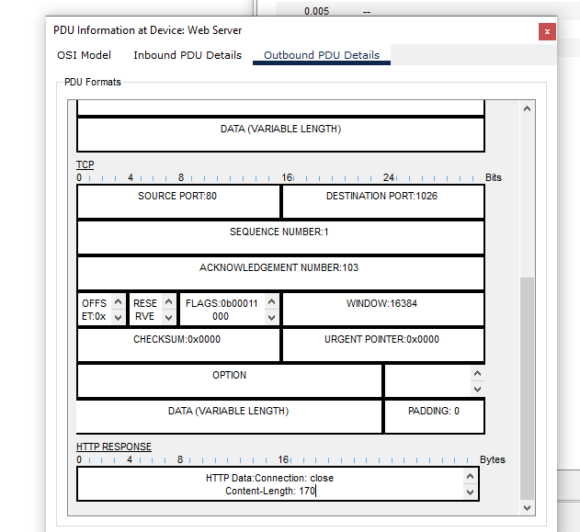
- 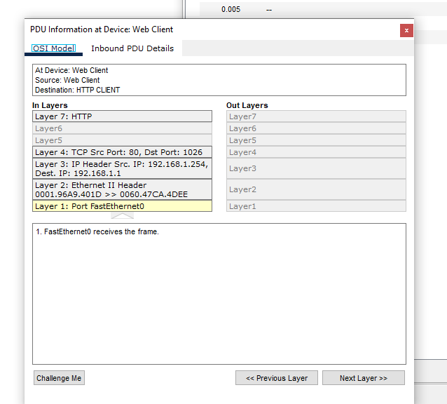
- 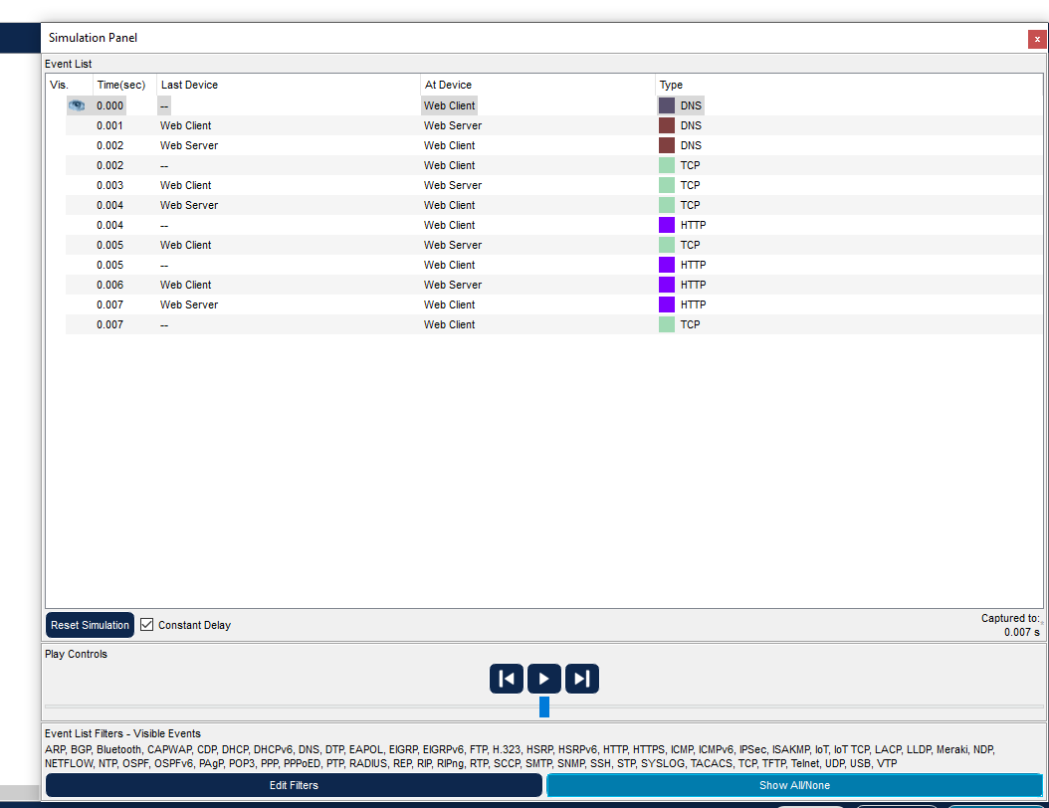
- 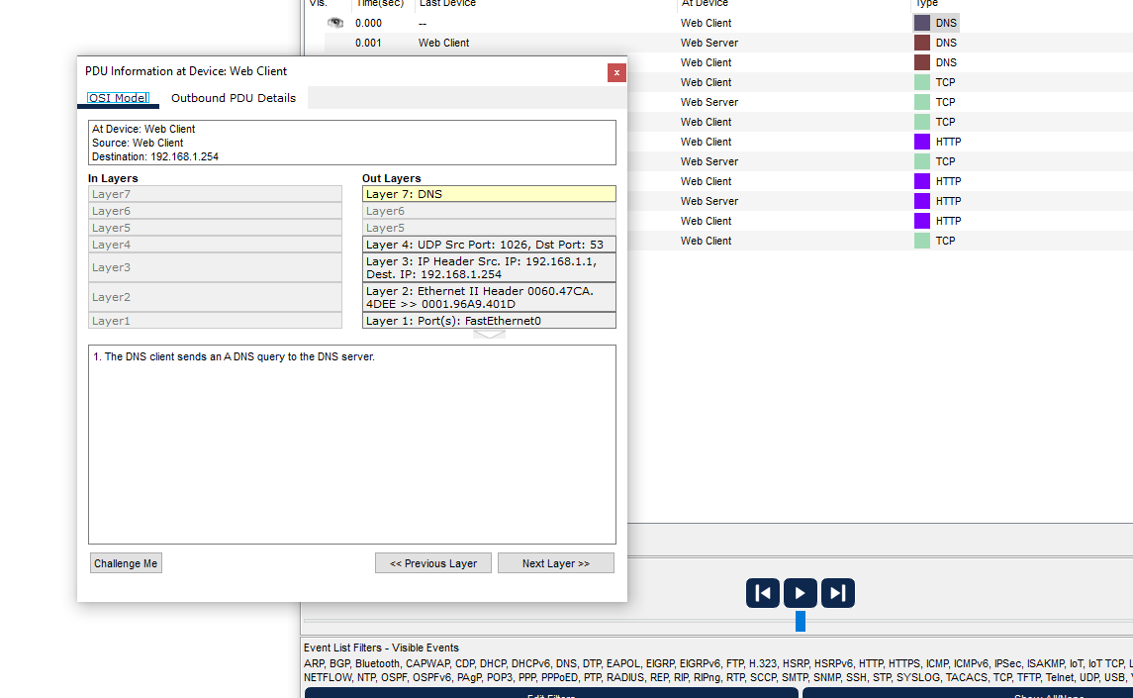
- 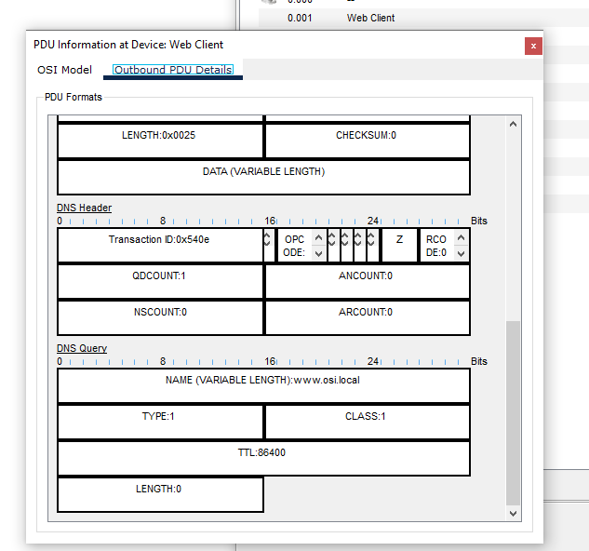
- 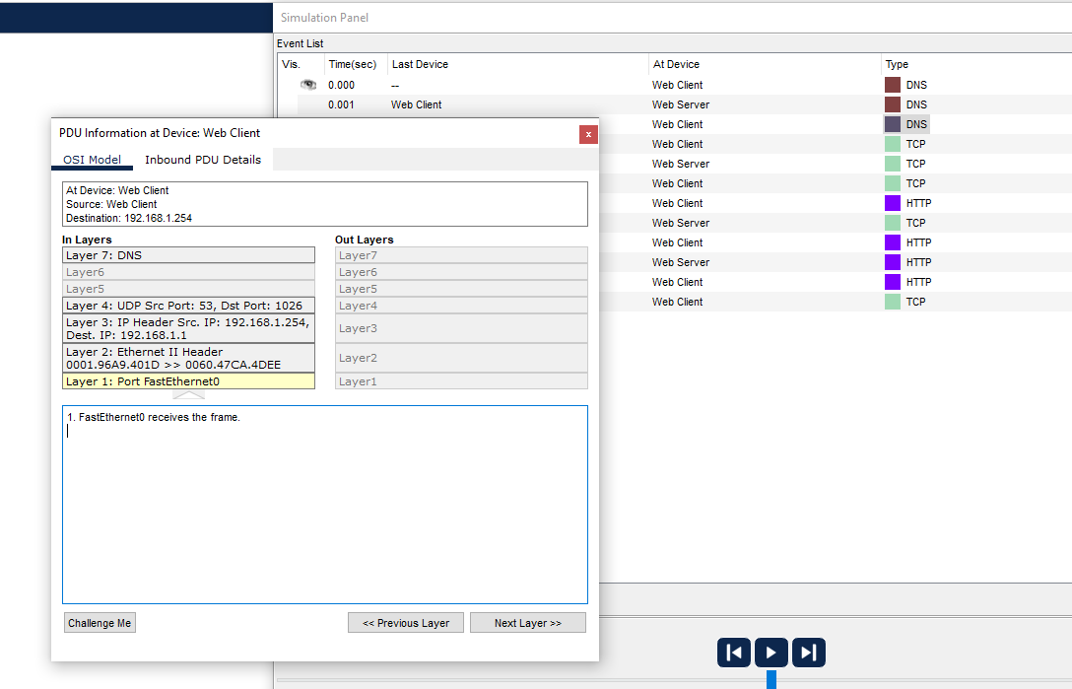
- 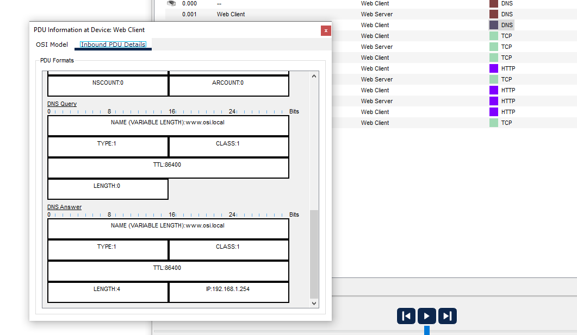
- 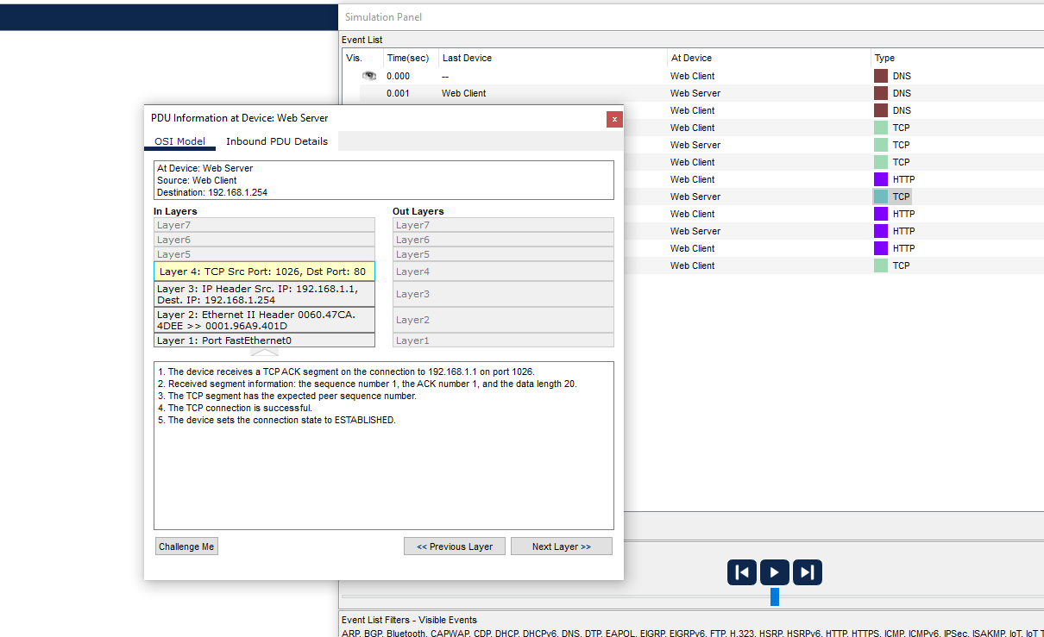
- 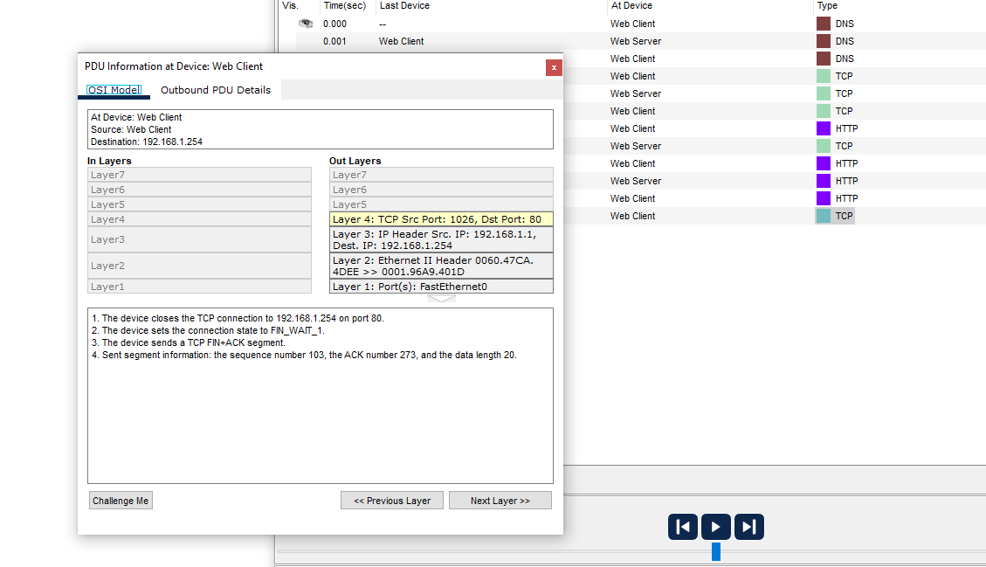
- 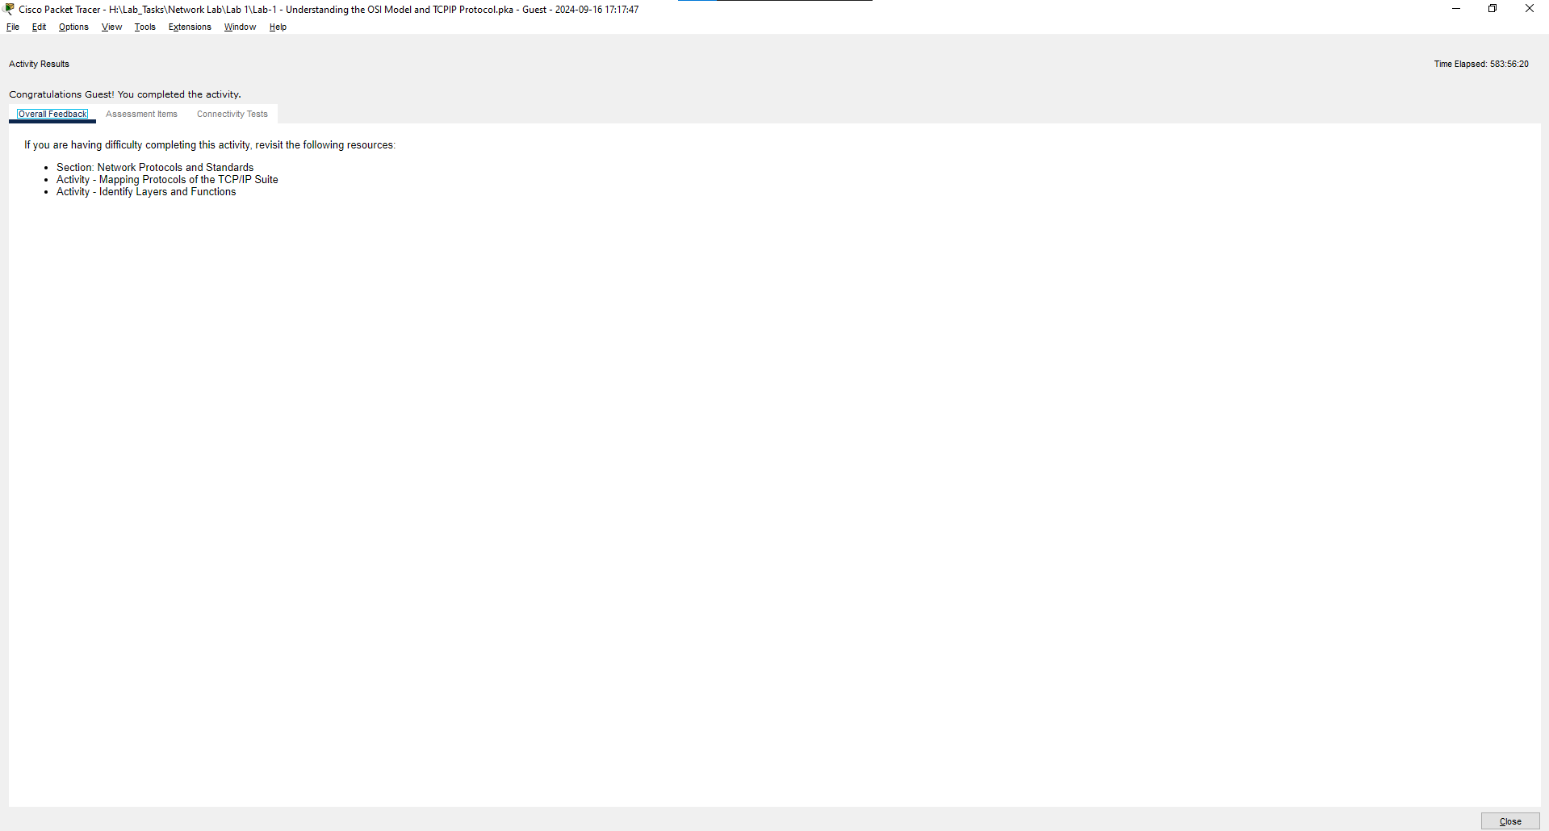

TOPOLOGIES IMPLEMENTATION
